**HOW SIMPLE LINEAR WORKS**

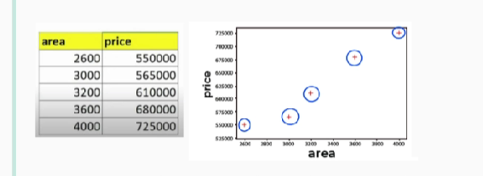

Above data is plotted as scatter in simple linear regression we draw multiple line on this data points on plot, and we have to calculate which line gives the less error.

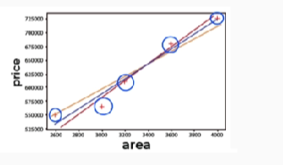

here the error is a data point which is not in the linear line, see the below image

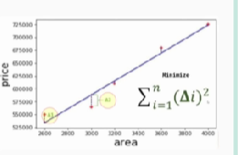

Second data point is not in linear line, so from all lines blue line gives us the less error with linear line. The errors are found by calculating the data points with the formula called delta. In delta formula we take two data points and finds the non-linearity, here point and point two is the error in the above line, in delta we square all the errors and sums all the squared errors.

After finding this best fit line that can be used to make prediction on new data, in the below SS the formula for predicting house price is there.

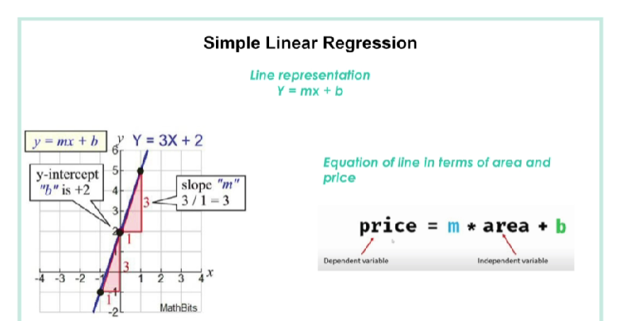

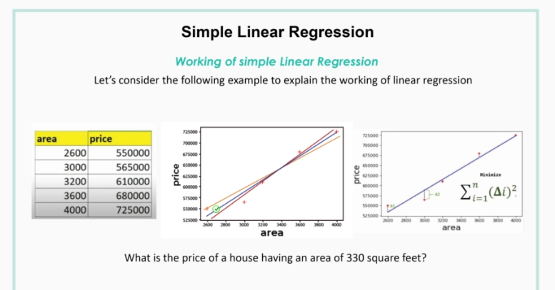

Here w